Learning Project
Age Range: EYFS
Weekly Maths Tasks (Aim to do 1 per day) | Weekly Reading Tasks (Aim to do 1 per day)
- Watch a Numberblocks clip each day at: BBC or CBeebies. Use this guide here to give you ideas on what to do with your children whilst watching an episode.  - Recite numbers daily from 0, 1, 2, 3, 4, . . . to 10/20/30 . . .? How far can you go?  Challenge: recite numbers backwards from 10/20/30. This can be done through playing hide and seek, singing number songs, chanting, board games etc.  - Sort everyday objects in different sets e.g. beads, lego/building bricks, pencils toy cars etc. Challenge: Can you sort each set again e.g by colour or size (different coloured lego/beads)  - Count different everyday objects/toys e.g. how many toy cars/ teddies/dolls/jigsaw pieces in a puzzle/building bricks do you have?  - Practice number facts for numbers from 3 to 10.  - Focus on a different number each day e.g. 4.  Make a set of 4 objects e.g. pencils/lego how many different ways can you split them into 2 parts (part, part, whole model – see example below and attached sheets if needed to support practical work for addition and subtraction)  - Draw the sets (you could draw the objects or draw a coloured circle or square to represent each one) and write the addition number sentence for each one.  - Can you find all possible answers? How will you know you have them all?  - Start to learn all the addition number facts by heart (especially the ones for 5 and 10)  Challenge: Can you find the subtraction/take away facts e.g. 3 – 2 = 1  - Sing Number songs to practice counting, reciting numbers in order, one more, one less using number songs: Five Little Ducks, Five Little Men, Ten Green Bottles  - Go on a shape hunt. What 2D and 3D shapes can you find? (in the house/garden).  - Can you remember the names of the 3D shapes? (cube, cuboid, sphere, cylinder, pyramid).  - How many edges/faces/corners do they have?  - Can you make a picture using 2D shapes? e.g. a house/rocket Can you label the shapes you have used? (circle, square, triangle, rectangle). | - Read a variety of books at home. Favourites can be repeated. Hearing the patterns of language in a story will support your child’s language development.  - With your child, look in magazines, newspapers and books for the tricky words they are currently learning. They could use a highlighter to highlight in magazines and newspapers.  - Daily reading approximately 10 minutes per day  - Ask an adult to share a story with you/read to you.  - Phonics/reading and writing – revisit Phonic sheets already sent home each week.  - practise reading the words by sounding it out and blending together to say the whole word.  - ask an adult to say a word from the sheet – can you write it? (remember to sound it out stretching the word and writing the sounds you can hear in the order they come)  - Choose words from your sheet and put them into sentences - say your sentence several times then write it. (try to make your sentences interesting and remember to start with a capital letter and end with a full stop.  - Watch episodes of Cbeebies alphablocks
Weekly Phonics Tasks (Aim to do 1 per day) | Weekly Writing Tasks (Aim to do 1 per day)
- Sing Nursery Rhymes and songs together. Add in actions and change the words. Can children think of different rhyming words to add in? Repeat old favourites and learn new rhymes. You can find an A-Z of Nursery Rhymes here.  - Daily phonics - Practice the sounds your child is working on and blend words. This can be oral blending (e.g. spoken out loud c-a-t) or written if appropriate. Interactive games.  - Sing the song ‘Daddy Finger’- Can your child change their voice for each person e.g. a deep voice for Daddy finger, a squeaky voice for Baby finger.  - Play phonics noughts and crosses. Draw out a grid and write a letter, digraph, trigraph or tricky word in each part of the grid. Take it in turns to name what is written in the grid. If you say it correctly you can add your nought or cross in that  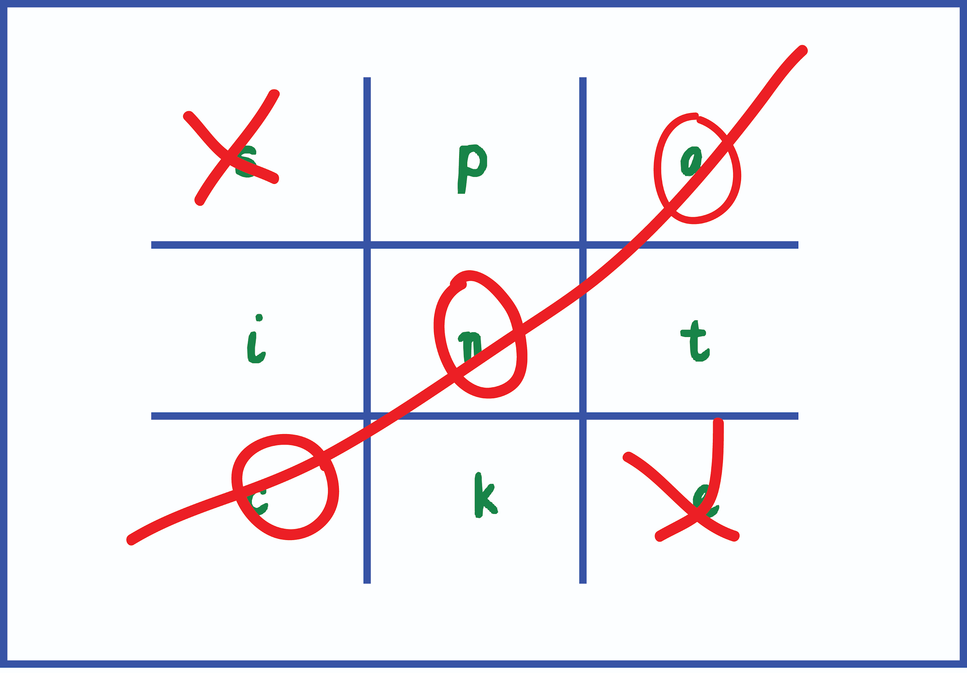  square.  - Phonics/reading and writing – revisit Phonic sheets already sent home each week.  - practise reading the words by sounding it out and blending together to say the whole word.  - ask an adult to say a word from the sheet – can you write it? (remember to sound it out stretching the word and writing the sounds you can hear in the order they come)  - Choose words from your sheet and put them into sentences - say your sentence several times then write it. (try to make your sentences interesting and remember to start with a capital letter and end with a full stop.  - Watch episodes of Cbeebies alphablocks  - High frequency/Tricky words – (Reception list was sent home at half term and another copy is below) These words cannot be read using phonics and need to be learnt by sight/memory. Practice a few each day until you can read them all by sight. Then learn to write them. (tip: don’t use letter sounds/phonics, use letter names when learning to spell). | - Ask your child to draw a picture of the people who live in their house. If they share time across two houses, draw who lives in each house. Can they label their family members using their phonics knowledge?  - Practice name writing. Can they write their first name? Middle name? Surname?  - Can they write the names of their family members? Do they know Mummy and Daddy’s real name? They could copy this or use their phonics knowledge. Can they write this? Using chalks, crayons, paint, felt tips.  - Ask your child to write out the tricky words they are working on at the moment on pieces of paper and turn them into a pairs game.  - Keep a daily diary – draw and write about what you do each day.  - Story maps and story writing – choose a story you know/ like/have enjoyed reading or hearing. Draw a map of the story – remember to think of the structure:  - beginning (setting and characters),  - middle (what is the problem/what happens  - end (how is it solved)  Can you use your map to tell the story to someone else?  Can you write the story in your own words?
Physical Development
(Moving and Handling/Health & self care)
(aim to do Daily)
- Practice forming the letters of the alphabet. We will upload links where you can find sheets to trace these. E.g. twinkl - also refer to the letter formation sheet (included)

- Draw/ copy handwriting patterns – use different colours/pencils/pens – this will help to develop good pencil control (see sheet with examples or find examples/sheets online e.g. twinkl)

- Go outside in the garden everyday to play and have fun and get some fresh air and exercise! e.g. Practice throwing and catching/ kicking a ball. Ride your bike. Practise jumping, hopping, star jumps, running etc. Create your own circuit of activities/make an obstacle course.
Learning Project - to be done throughout the week
Understanding the World (The World)
- Create a simple weather chart and record the weather each day. What symbols will you use for sun / rain /clouds etc? (tip: think about the ones we use in class to help you with ideas).
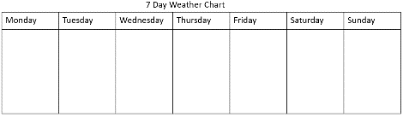

- Choose an animal to find out about and create an information fact file e.g. where it lives, what it looks like, what it can do, what it eats etc. add a picture/draw a picture of your chosen animal.
- Go outside in the garden :
- Use you senses - what can you see/hear/feel/smell?
- look for patterns in the environment e.g brick walls, paving slabs, grates fences. Can you draw them/make rubbings with a crayon and paper?
Understanding the World - People and communities (including Religious Education)
- Find out about the Christian story of Easter – The events of Holy Week from Palm Sunday to Good Friday. What happened on Easter day?
Creative (Exploring and using media and materials) – choose activities from:
- Junk modelling using 3D shapes - make a model using recyclable materials - cardboard boxes, packaging, tubes etc. e.g. make a house, rocket, robot, /animal/dinosaur etc)
- Make musical instruments e.g. shakers using a recyclable container and beans/rice/beads.
- Listen to music/sing songs – sing favourite songs; Go to: www.musicaltoad.co.uk (Mr Shepherd who teaches our music on Wednesday mornings has all the songs and more that we have been learning on his website)
- Observational drawing
- choose something from the garden/nature to draw e.g. a flower/plant/leaf – look closely at the detail. Can you put this into your drawing?
- Portraits – choose someone in your family to draw/paint
- Draw/paint a picture/ make a collage
e.g. - what you can see from a window in your house
- a character or a scene from a story you are reading/ watching on DVD/ computer
Additional learning resources parents may wish to engage with
Classroom Secrets Learning Packs - These packs are split into different year groups and include activities linked to reading, writing, maths and practical ideas you can do around the home.
Twinkl - to access these resources click on the link and sign up using your own email address and creating your own password. Use the offer code UKTWINKLHELPS.
Headteacherchat - This is a blog that has links to various learning platforms. Lots of these are free to access.
www.phonicsplay.co.uk
choose from phase 2 and phase 3 phonics - some of the games are free and don’t need you to subscribe
www.topmarks.co.uk
Go to the Learning Resources tab for Maths and English online activities and games for different ages e.g. 3-5/5-7/7-11 years
- English activities: – e.g. letters & sounds; punctuation; words and spelling; learning to read; stories
- Maths activities: - e.g. counting, ordering, sequencing numbers; place value; addition & subtraction shapes, measures
There is also a useful Parent’s Resources tab, with useful information and ideas to help your child with their learning.

www.oxfordowl.co.uk
Oxford Owl for Home – Free resources to support learning at home – also check the new parent website link
- advice & support for parents
- Educational activities and games
- Free eBook library for 3- 11 Year olds
www.musicaltoad.co.uk
Mr Shepherd (our music teacher) website with the music and songs we have been learning with him in class.
#TheLearningProjects

